Experiment 5.3
Determination and plotting of Potential Difference for Negative Charge (Fixed r1)

Code File Name: Exp5_3_NegativeCharge_PD.m
Code
clc;
epsilon=8.854e-12;
k=1/(4*pi*epsilon);
q=-1e-6;
r1=1;
r2=linspace(1.1,10,100);
V=k*q*(1/r1 - 1./r2);
plot(r2,V,'LineWidth',2);
xlabel('r2 (m)');
ylabel('Potential Difference (V)');
title('Negative charge, fixed r1');
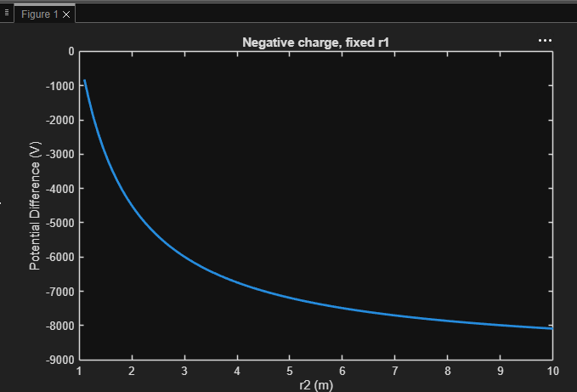
Output Graph

